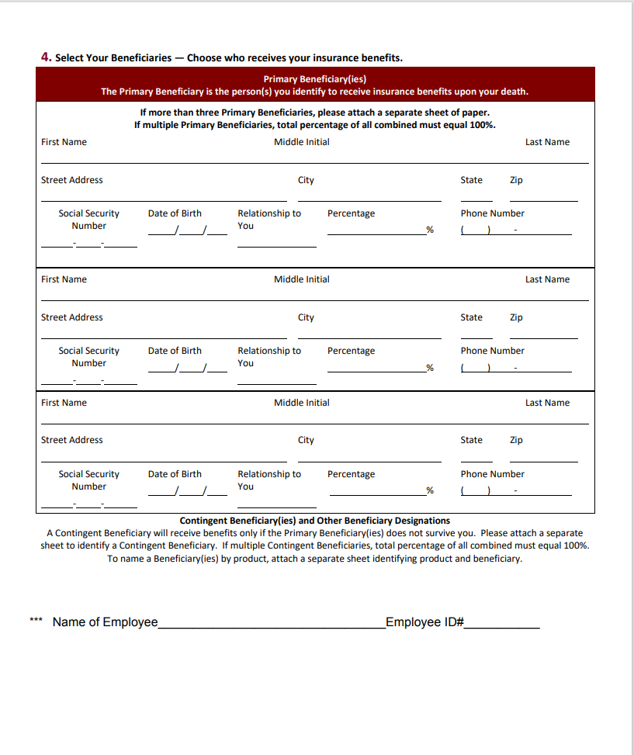

Lincoln Financial Life and Disability Beneficiary Form